
Version 8.1
Updates history

Version 8.1.1
Compatibility 7.2 | No

Version 8.1.1.063 | 06/07/2010

New field related to thermic module (TM): A field labelled ERRTHERM is added into Detail2 table as well as Fen table for WPR users. This field will be filled with the potential error messages from thermic computation.

Version 8.1.1.059 | 06/07/2010

Addition of a new user right for thermic module: A new user right is available into the User record, allowing the set up of Thermic Module TM settings.

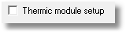

Version 8.1.1.058 | 06/07/2010

Importation of installation articles within WinPro/D: WinPro/D offers now the ability to automatically answer the question “Do you want to import installation articles?” when importing a quotation (release note 8.1.1.047).
Here is the needed key to add into the Settings table of WinPro/D, as well as the WinPro/D’s behaviour according this key:

[WinProD]
AutoImportPose = 0 Ask the question (default behaviour).
= 1 Auto answer yes.
= 2 Auto answer no.

Filters on multi-sashes for fittings feature: The behaviour of the key enabling the Multi-Sashes for Fittings frame feature (refer to previous release notes) has been modified to allow to filter into the fittings frame the sashes list from the same system or not.

[System]
Quinc Multi Ouvrant = 0 No multi-sashes for fittings frame feature (default).
= 1 Multiple sashes from the same system.
= 2 Multiple sashes from all systems.

Version 8.1.1.058 | 06/07/2010

Modification of the _Quantity variable behaviour: Until now, the _Quantity variable was initialized to zero by default, which might involve error message of “division by zero” when this variable is used into a division operation. This variable is now set to zero by default.

Version 8.1.1.057 | 06/07/2010

Import of decorative composed panels (IPDC module): A new module IPDC – Import of decorative composed panel, has been added.
This module allows importation and automatic creation of Harinck’s decorative composed panels. WinPro allows now to import an Excel file provided by the panel supplier Harinck.
This file contains all needed settings for the various panels.
From this Excel file, WinPro will create panels as well as needed set up and articles associated to the panels.
In order to import such a file from Ha rinck supplier, you may use menu Tools | Import composed decorative panels.

New field into table VitreCde: Two new fields are added to table VitreCde. They will be filled with the thickness of the first and second spacer (in case of triple glass unit) of a glazing, respectively EPINTERC and EPINTERC2.

Warm-edges printing: At the WarmEdge record level, a checkbox allows now to choose when the Warm-edge is to be printed or not onto main documents (Quote, confirmation, factory docs, glass order form, etc...).
This feature has been added to avoid printing this information when the warm-edge input by the user is not a warm-edge.
For instance : « Warm-Edge : DUMMY ».

IMPA module for articles creation/importation: This module for Articles Importation IMPA, used to generate an articles table from a DBF file (compatible with Excel), is now compliant with mySQL database format.
This module was only FoxPro format compliant previously.

Version 8.1.1.053 | 06/07/2010

Programmed glass supplier: You may now define a glass supplier by rule. This feature is enabled through a new key into Settings table from one hand, and with setting up a formula to assign a supplier from a second hand.

[Glass]
Supplier by formula = 0 Feature disabled (default).
= 1 Feature enabled, the glass supplier may be set by formula.

When you enable this functionality, it is imperative to set a specific identifier for each supplier, for glass suppliers as well as for others material suppliers.
This is to be set into the supplier record, into the dedicated field from the "Delivery and supply" tab.

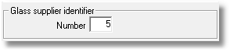

The glass supplier may be then defined by formula using the global filling variable _FillingSupplier, indexed onto the filling number, as follows:
_FillingSupplier [FillingIndex] := ID of the supplier

Version 8.1.1.050 | 06/07/2010

Teleglass EDI and composed glazings: Addition to the glazing EDI for protocole Teleglass, the concatened code of a composed glazing is now written into the file generated by the EDI link.

Version 8.1.1.049 | 06/07/2010

Composed panel and composed glazing: It is now possible to use a composed glazing with a composed panel set up, with keeping in mind the following rules:

- When the glazing code is not defined into the glazing tab of a composed panel set up, Winpro uses the glazing as it is input into the window tab of the quote or order.

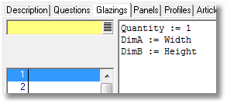

- When the glazing code is set into this tab of the composed panel, the questions from the glass unit need to be copied into the composed panel question set.

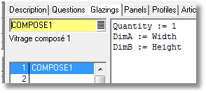

Version 8.1.1.047 | 27/06/2010

Installation articles into WinPro/D: When importing a quotation into WinPro/D, the user is now invited to confirm if Installation Articles need to be considered or not.
When importing a quotation, a new dialog " Do you want to import installation articles into the quotation? " is displayed:
- When answering “YES“, installation articles will be imported along with the content of the Installation tab of the order.
- When answering “NO“, installation articles are not imported, the installation tab of the quote is also ignored.
For exports, when the user answer “No“ to the question “Is this file for the window maker?“, the installation articles are systematically exported within the quotation.

Version 8.1.1.024 | 27/06/2010

Filtered list of orders into invoice and delivery processes: You may now display a filtered list of orders into dialogs “Reprint invoices” and “Reprint delivery note” instead of a ccomplete list, with creating the following key into Settings table:
[System]
FilterOrder = 0 Complete list (base behaviour, default).
= 1 Filtered list.

When the key is set to 1, the list of order will be displayed when the user defines at least one selection filter in the dialog.

Version 8.1.1.004 | 27/06/2010

Enhancement concerning texts for customer documents: Texts at start/end of customer documents (created into preferences) are now transferred into the database, within a new table labelled OrderText.
Les textes que vous créerez seront dorénavant enregistrés dans cette table.
To import existing texts, the old format files has to be located into a “Data“ directory of the base path (the directory needs to be created for a mySQL version of the program if not exists, and files should be copied into it).
At WinPro or WinPro/D startup, you will be asked to import the text files, and files will be deleted afterward.

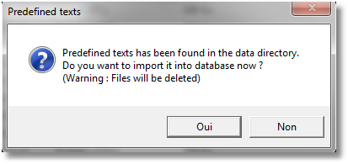
From menu Tools | Preferences Texts tab, a button is also available in case you need to generate old format files from the recorded texts. Files will be recorded into an “OrderText” sub directory of the base path.

Version 8.1.1.003

Composed decorative panel: Addition of a new filling type : "Decorative composed panel". This filling type allows to manage with a Harinck’s panels database.
This filling type is input like the other filling types (glazing or panel, composed or not) into an order.

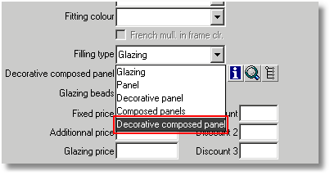
This new filling type may be set up through an dedicated interface similar to the composed panel interface. Those set up dialogs are available either through the button located into the button bar on the top main window, or through menu Technic | Window | Decorative composed panel.

The interface is divided into a single screen containing various tabs:

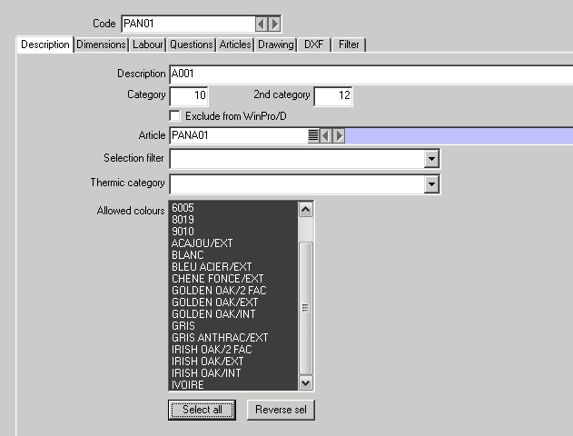

- The Description tab is intented to define a description, two levels of categories, an option to include the panel into a WinPro/D database or not, an article to be ordered to the supplier, a selection filter (release note 8.02), a thermic category used for thermic computation (depending on modules, release note 8.1.0) as well as the list of allowed colours to be used into the panel.
- The Dimension tab is used to define the default thickness of the panel as well as limits of dimensions for the panel usage.
- The Labour tab is intended to set up additionnal costs for panel pricing, as well as a code and time for labour in case of shaped panel.
- The Question tab allows to define a set of questions and answers that would be used within Articles or Drawing tabs.
- The Article tab contains the list of articles to consume. The consumption of those article determines the panel price. Each article may have a macro ID as well as a macro description (like with composed glazing feature). Both strings will affect macros "@...@", that can be used into the description of the main article set for the panel. The TotalThickness variable may be used into the article formulas.
- The Drawing tab contains the list of WinPro’s drawings to be used to display or print the panel. The TotalThickness variable may be used into the drawing formulas.
- The Dxf tab contains the list of WinPro’s dxfthat may be used according the panel thickness.

Version 8.1.1.x

New module GLPV Production Line Management for Roller Shutter : This new optional module GLPV is intended for roller shutter fabricators to be able to affect a production line and prepare production batches according the roller box or roller curtain. This module is exclusively combined to module VO, it cannot be used along with module VO2.

New module TMS Simplifies Thermic Module : This new module is designed from the full Thermic Module TM, with a significant simplification.
The base computation method is kept as is here. However, WinPro just fetches the Ψg value assigned by default to the warm-edge (depending on its thickness). There are then no tables to fill in for the variation of the Ψg value according the combination of profiles, filling thickness and Ug values. The final result of thermic computation is a value approaching very nearly of the real value, with staying between limits of what is allowed for this computation.
Attention this module is only available under FoxPro database format. Under mySQL format database, the standard TM module remains the only one available.

